

|  |  |
| --- | --- |
|  | Lab 7: Domain Analysis Modeling & Sequence Diagram |
|  |  |
|  | Akshar Panchani ID- 202101522  IT314 Software Engineering  9/26/23 |

**Q.1**. Considering the given piece of text from lab.

1. Complete the use case diagram for the above problem text along with use case documentation for “issue Book” use case.

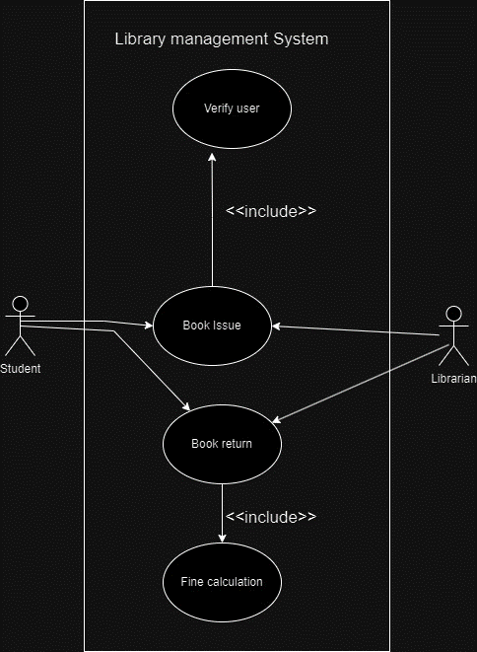

**Use Case Documentation**: Issue Book

**Use Case Name**: Book Issuance

**Primary Actor:** Librarian

**Other Actors:** Student, Database (Book Catalogue, Members) Stakeholders and Interests

-Librarian: Aims to ensure efficient book issuance, checking student membership, and maintaining accurate book and student records.

-Student: Desires to successfully borrow a book from the library.

-**Preconditions**: Librarian must be identified and authenticated.

**Success Guarantee/Goals:**

- The book's status in the catalogue is updated to "issued."

- The student's profile records the book issuance information.

**Trigger:** A student approaches the librarian with a book to be issued.

**Main Scenario:**

1. The student arrives at the librarian's desk with a book for issuance.

2. The librarian verifies the student's library membership.

3. The librarian updates the book's status to "issued."

4. The librarian updates the student's profile to reflect the book issuance.

5. The student receives the issued book.

**Extensions (Alternative Flow):**

- If the system fails at any point:

1. The system initiates a robust recovery process.

2. If anomalies are detected in the prior state,

a. The issuance process is canceled and restarted.

b. The librarian can manually update the issuance process.

-If the student requests not to issue the book at any time:

1. The issuance transaction is canceled, and the book is returned to the librarian.

2. If the student's membership is invalid: The issuance transaction is canceled, and the book is returned to the librarian.

3. If the book is currently held by someone else: The issuance transaction is canceled, and the book is returned to the librarian.

**Special Requirements:**

- Robust recovery mechanisms to handle system failures.

- Swift authorization response for efficient processing.

- Timely updates to the system to ensure accurate records.

**Postconditions:** The system returns to the dashboard, ready for another book issuance or return transaction.

2. The sequence diagram for the “issue book” use case.

Entities:

* Book: Represents individual book with ISBN to check availability
* Student: Student with unique student ID borrow books from library
* Transaction: Represents any interaction between student and library.

Boundary objects:

* Librarian/Student Interface: The library management system has the interface where the transaction would happen and both of them interact.
* Barcode reader (If available): Can be considered as a hardware component used to read barcode on the book.

Control objects:

* Fine calculator: Calculates fine for the delayed submitted books.
* Database system: Has the collection of information of books, verified librarian and student information.
* LMS: This Library management system itself can be considered as control objects as it manages and organize all the procedure or transaction.

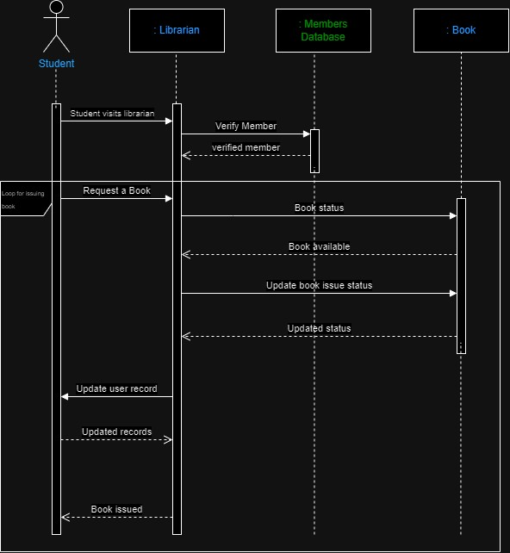

3. Draw the analysis object diagram for the “issueBook” use case analysis.

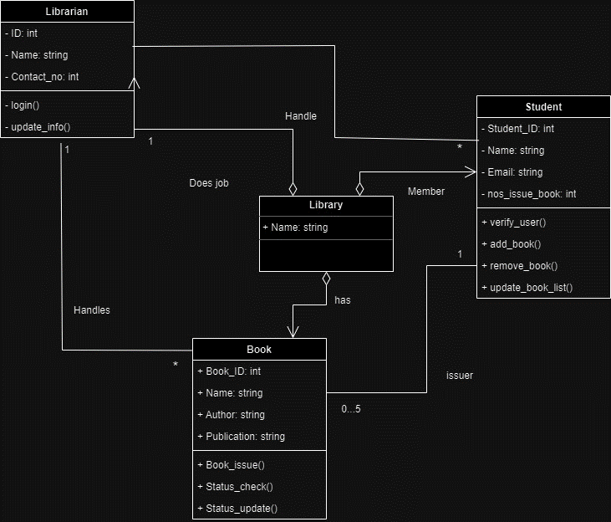

Q.2.Draw a sequence diagram that represents this process. Make sure to show when is each actor participating in the process. Also, show the operation that is carried out during each interaction, and what its arguments are.

